**Project title: Car repair shop**

**Author: Sandor Marian**

**Group: 30421**

# Task Description

“You are supposed to partially simulate the activity of a car repair shop. The repair shop can accommodate up to 20 cars in the workshop and in the yard. Every car can be in one of the following states: waiting for diagnose, diagnosed, waiting for parts, in repair and ready. When a car is ready, the owner is called to pick the car. He/she has to pay for the cost of the repair and then, the car leaves the shop. There can be no more than 12 cars in repair (i.e. in the workshop) at any time.

As you know, a car may be identified by its license plate. The car also has an owner who has a phone number.

When a car is brought to the workshop, it is admitted if there is an available place for it. Then it passes through the states enumerated above (waiting for parts may be skipped if there are parts available).

The simulation takes place in 1 hour steps.

You are supposed to simulate the activity of up this car repair, and provide a view of this.

At every check-in point there will be a queue of cars waiting to enter (note that the queue may be empty) .

All the relevant data (initial configuration, schedule, history data) should be stored in flat files.

The application should allow for saving the state and restoring it (serialization). A dashboard view should show the activity involved in this simulation. This should be a GUI which you should design.

Complete this brief specification with the elements needed (as you see this is not described in detail) and develop a project to simulate the airport check-in activity.”

First of all, we need to identify the different objects from which the car repair shop is composed. It is natural to say that there must be cars with different owners, a set of parts that will be used in the repair process and some way to store these parts.

Starting with the car, we begin by defining its owner which is a person that has a name and a phone number. This will serve as the contact for when the car is repaired and must be picked up by its owner. The car itself must have some kind of identification which as in real life will be the license plate. Moving on, it is very easy to classify the problems of the cars by reducing it to only a problematic part. There are 6 different parts that our repair shop works with: Engines, Gearboxes, Doors, Tires, Windshields and Seats. Each part could be identify by an id ( if provided ) but nonetheless it must have a price.

The stock of the repair shop deals only with the parts that are available at the moment for repairs. It must be able to offer information about the status of parts that it contains, the amount and of course receiving new parts from time to time.

When looking at the repair shop it is obvious that this is what controls all the cars that come in and the stock. To make things easier to work with, we define registrations that hold account of the cars in the shop. That being said, when the shop receives a car it creates a registration for it and as long as it is in the shop it is seen as a registration. Now, the registration contains a few more fields than the car itself, it holds the status in which the car is (Waiting for diagnose, Diagnosed, Waiting for parts, Ready to repair, In repair, Ready), the repairing cost ( part price + workmanship ) as well as the time needed for the car to be repaired.

For a better understanding let’s analyze the process for a car to get repaired. First the shop receives a car that has an owner and is identified by its license plate. The shop creates a registration for it setting the status to “Waiting for diagnose”. In time, its status goes from “Waiting for diagnose” to “Diagnosed” than if the part that needs to be replaced is on the stock it goes to “Ready to repair” otherwise its status is set to “Waiting for parts” and remains like this until the part comes available on the stock and then goes to “Ready to repair”. When the car enters in the workshop its status becomes “In repair” and a time (in minutes) is added to the registration meaning the time it needs for the shop to repair the car. In the end, when the shop finished repairing the car, the new status becomes “Ready” which means the shop has announced the owner of the car to come. In order for the owner to receive its car, the cost on the registration must be paid.

In order to simulate the activity of the car repair shop, we need to somehow generate random data. The name and phone number of a person as well as the license plate of a car can be easily generated and the logic is pretty trivial. The stock get randomly updated and it receives a random part out of the ones we have defined. To get a bit more in depth with the simulation, there is a clock that holds the time in hours and minutes and also the date. Cars are randomly added to a queue from which are given to the repair shop if there is space. All of this are controlled by a timer which is a separate thread and acts as the clock signal for the simulation. In this way the clock is updated once every 10 milliseconds.

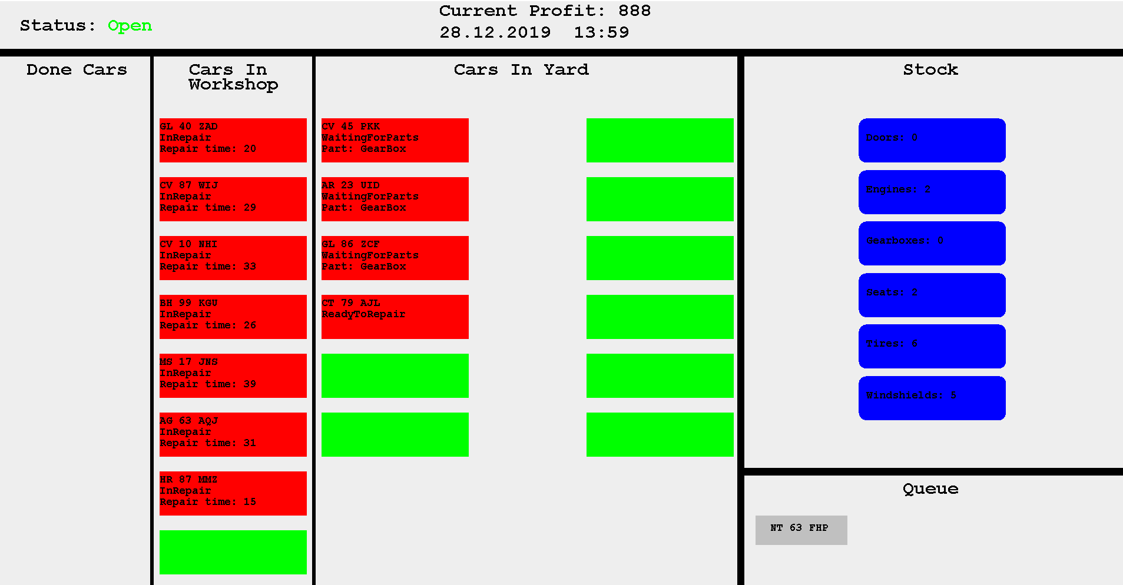

The dashboard is pretty much self explanatory. We have three section for the registrations in the repair shop categorized by in yard or in shop and the leftmost column is for the done registration (It displays the owners name and phone number). On the right, there is the stock (the number of items for each different part) and under it the queue of cars randomly generated that are waiting to enter the repair shop. On the top, the current time and the profit ( in the given day ) are displayed in the middle and on the left there is the status of the shop ( opened form 8:00 to 20:00 ).

The records of the cars that was in the workshop as well as the profit per day is kept in two separate csv files (CarRecord and ProfitRecord). CarRecord stores on each row the license plate of a car and the date and time of when it entered and exited the car repair shop. ProfitRecord displays on each row the date and the profit of the repair shop from that day.

# Class Discovery

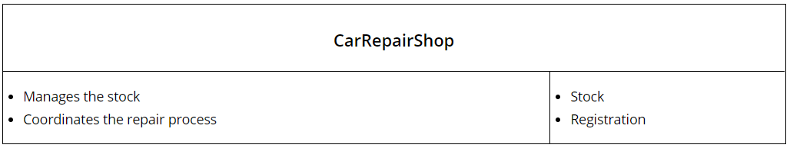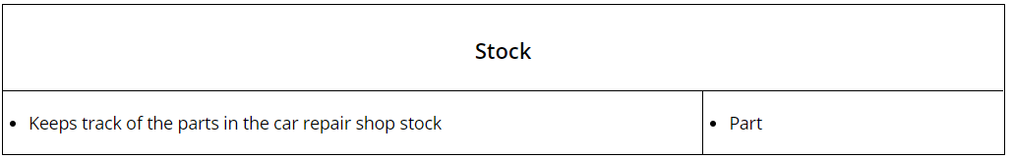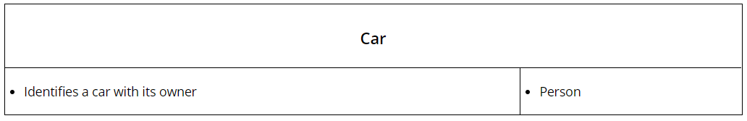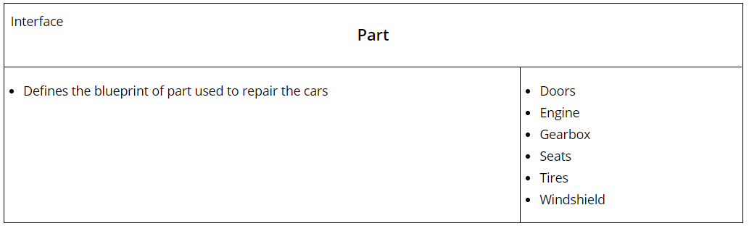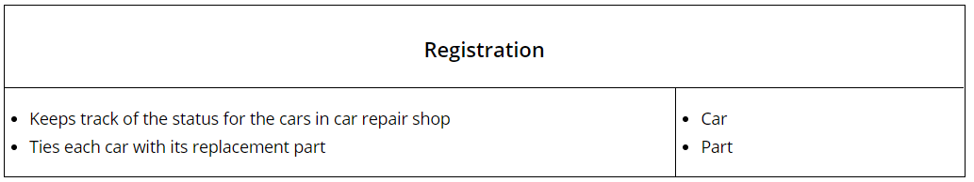

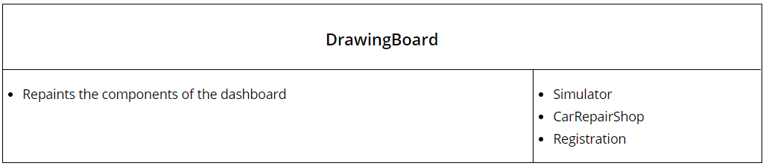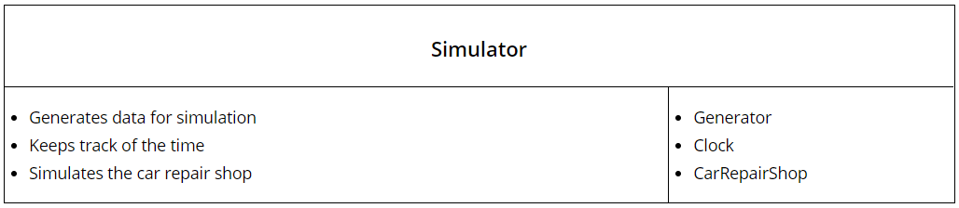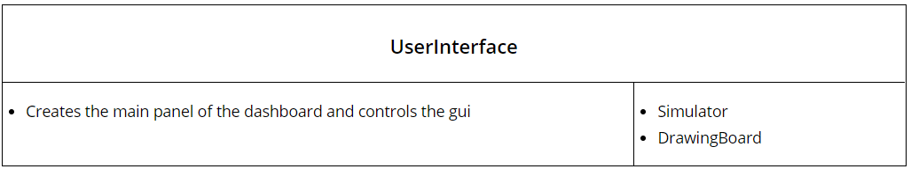

# Class Diagram

